**Matthew Yeseta**

**Gen AI Architect**

**Here is how one must lead as a Gen AI Architect**

**Engineering Leadership, Managing Budgeting & Forecasts, Accountability**

Gen AI LLM, in leadership that transcends technical prowess, focusing on people, accountability, and strategic alignment. It requires balancing innovation with fiscal responsibility, ensuring that projects meet both executive expectations and customer needs.

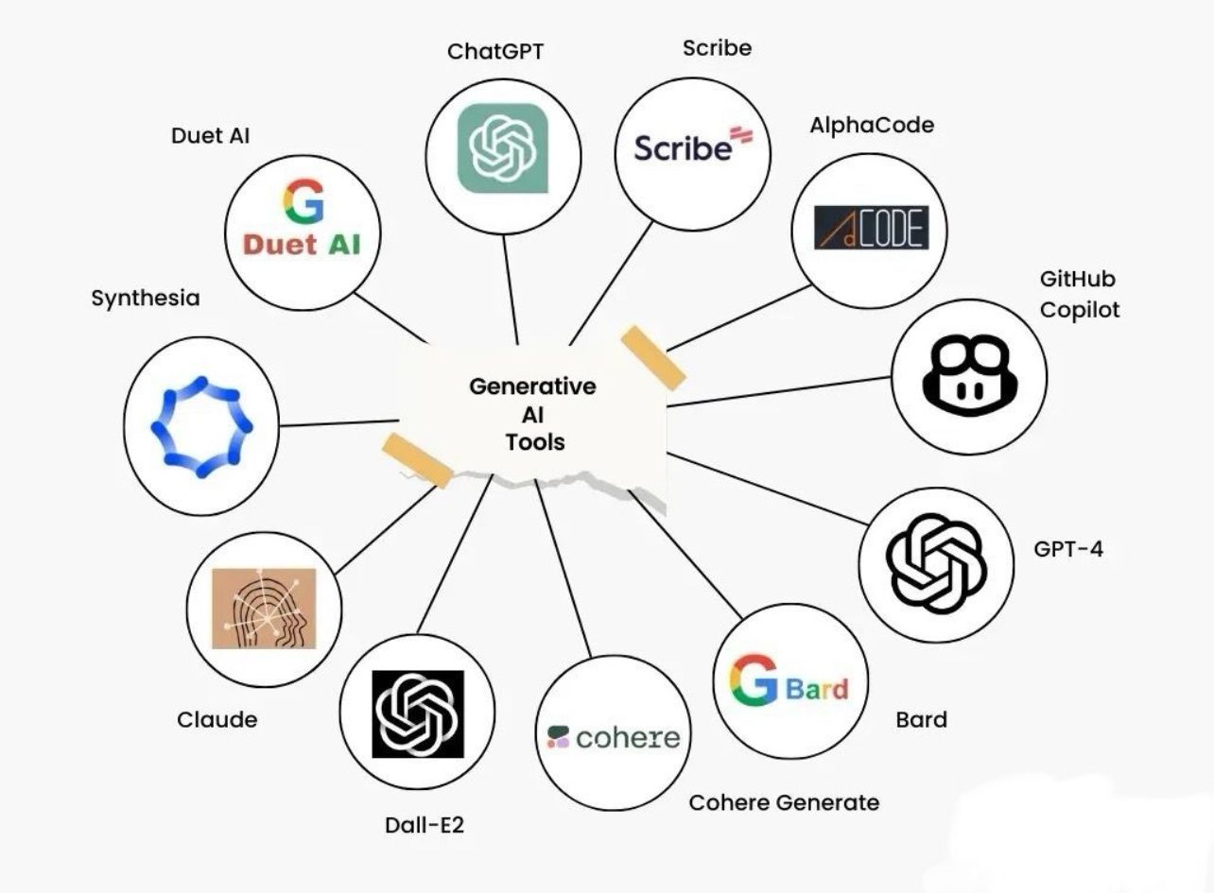

Here is how I bring my people and tech leadership accomplishments (again) to be hired and lead for the following soft talents for leadership in Engineering, Data Science Management, Analytics, Digital

**Marketing, Gen AI LLM in team talent, collaboration, business focus satisfaction.**   
  
Balancing innovation with fiscal responsibility is key to managing financial and project accountability. By focusing on these areas, a Senior Manager of Engineering can ensure projects are delivered on time, within budget, and with maximum impact, ultimately improving revenue and customer satisfaction.

**Great Engineering Leadership: Beyond Technical Expertise**  
  
Effective engineering leadership goes beyond technical skills; it’s about people and accountability. Leading projects requires not only managing financial budgets and forecasts but also aligning them with executive and customer expectations. Budgets should drive strategic decisions and project vision. Key to this is maintaining accountability, transparency, and integrity that mangers can ensure teams are held accountable for budgets and time-to-market deliveries.

**Managing Budgeting and Forecasting**  
  
Managing engineering budgets demands a balance between cost efficiency and strategic investment. The foundation of budgeting and forecasting lies in aligning with executive expectations. Before finalizing budgets, they must be verified and aligned with the organization’s fiscal goals. In my role overseeing Smart-City projects in China, I developed budget forecasts that considered both immediate needs and long-term objectives. Managers must define project scope, resource requirements, estimate costs, and regularly review financial performance to adjust forecasts as needed.  
  
**Ensuring Accountability and Timely Deliveries**  
  
Accountability and transparency are crucial in holding teams responsible for budgets, time-to-market deliveries, and product quality. Establish clear accountability structures, ensure everyone understands the expectations, and schedule regular performance reviews. Engage in continuous feedback to maintain project momentum and drive improvements that enhance revenue streams and customer loyalty.